Solenoid Driver Board Assembly Instructions

Board Version 1.2, Dated 1/2022

Mike Hilton, Eckerd College

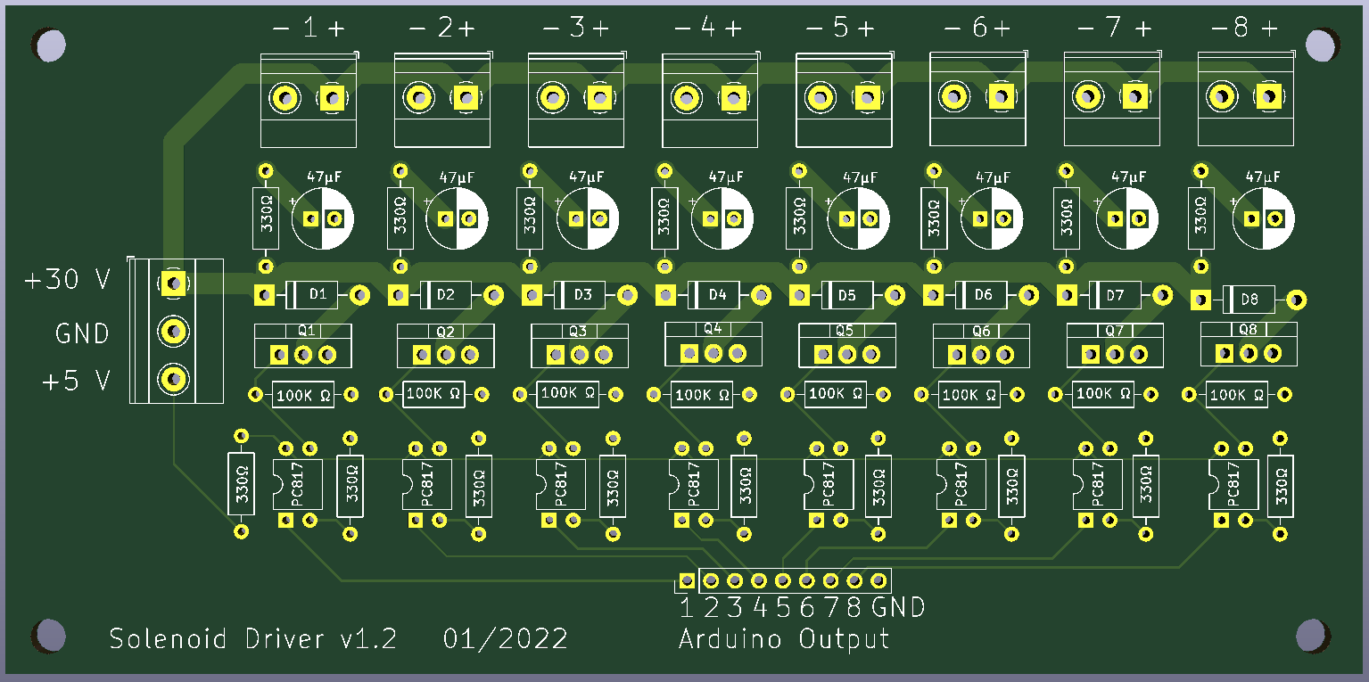

**Purpose**

The solenoid driver board allows an Arduino to control 8 high-voltage, high-current devices such as solenoids. The devices are triggered by digital output pins on the Arduino. The Arduino is electrically isolated from the devices to protect the Arduino from stray currents or voltage spikes in the external circuits.

When solenoids are turned off, a large current is induced in the coil as the magnetic field collapses. Each output channel includes RC snubber circuits and diodes to help dissipate this current safely.

**Usage**

Each external device is associated with an output pin of the Arduino. When the Arduino pin is high, the external device is connected to external ground, completing a circuit, and turning on the device. The ground side of an external device should be connected to the negative terminal of a driver channel. As a convenience, the positive terminal of each driver channel is connected to external VCC, which is marked as +30 V on the 3-input power connector. (Any positive voltage can be connected to VCC; it does not have to be +30 Volts.)

The +5 V input of the 3-input power connector powers the output side of the PC817 opto-isolator chip and provides the voltage that will appear on the gate of the power MOSFET. This voltage does not have to be +5 V; it can be +12 V if you wish.

The MOSFET used in this circuit is the FQP30N06L, which can sink 32 amps at 60 V for short periods of time. The MOSFET switching circuit on this board is fairly generic, so you can use a different MOSFET and gate-source resistor if desired.

**Parts List**

|  |  |
| --- | --- |
| *Quantity* | *Description* |
| 17 | 330 Ohm Resistors |
| 8 | 100K Ohm Resistors |
| 8 | 1N4005 Diodes |
| 8 | 47μF Electrolytic Capacitors |
| 8 | PC817 Opto-isolator Chips |
| 8 | FQP30N06L Power MOSFETs |
| 8 | 2-Pin Screw Terminal Block Connector, 5mm Pitch (External Outputs) |
| 1 | 3-Pin Screw Terminal Block Connector, 5mm Pitch (External Power) |
| 1 | 9-Pin Header, 2.54mm Pitch (Arduino Header Pins) |

**Assembly Instructions**

1. Solder all resistors in place.
2. Solder all diodes in place.
3. Solder the PC817 opto-isolator chips in place. There is a small circle on the face of the chips to indicate pin 1, which should be oriented in the same direction as the semicircular cutout on each of the circuit board’s chip outlines.
4. Solder on the 2-pin screw terminals. The openings for the wires should face the top edge of the board.
5. Solder on the 3-pin screw terminal. The openings for the wires should face the left edge of the board.
6. Solder the Arduino header pins in place.
7. Solder the capacitors in place.
8. Solder the power MOSFETs in place. The side with the metal heat sink should be facing the top of the board.

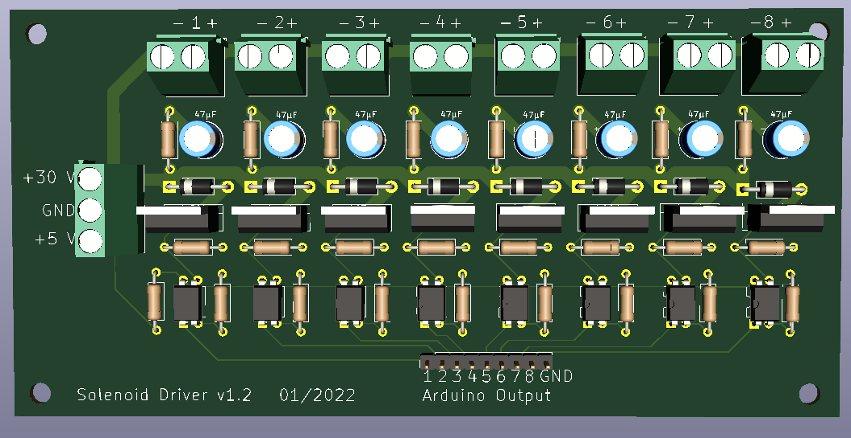

**Testing Procedure**

Connecting a solenoid to the circuit for testing is not recommended because if there is a problem, it could result in large currents flowing through the solenoid and melting the coils. Instead, use an LED to detect output from the switching transistor. 